ENTERPRISE DEVOPS & GITOPS PLATFORM
Final Capstone Project — Fitness Tracker Application Delivery

Submitted by: Jeevan C
Course: Enterprise DevOps Engineer Capstone
GitHub Repository: https://github.com/JeevanC31/Fitness_Tracker
Submission Date: June 11, 2026

PART I: ASSIGNMENT SPECIFICATION
The objective of this project is to build a fully automated software delivery lifecycle for a cloud-native Fitness Tracker application using Agile planning, CI/CD automation, GitOps deployment, Kubernetes platform engineering, monitoring, and AI-assisted operations.
Required Deliverables
- Deliverable 1: Jira Agile Board — Epics, Stories, Tasks, Sub-tasks.
- Deliverable 2: GitHub Repository Strategy — branching, PRs, merge workflow.
- Deliverable 3: GitHub Actions CI Pipeline — quality checks, testing, artifact prep.
- Deliverable 4: SonarQube Quality Gate Report — bugs, vulnerabilities, code smells.
- Deliverable 5: Production-grade Dockerfile and container packaging.
- Deliverable 6: Python automation script — promote Docker images without rebuilding.
- Deliverable 7: Kubernetes manifests — Namespace, Deployment, Service, ConfigMap, Secrets.
- Deliverable 8: Helm Charts — parameterized values for Dev, Staging, Production.
- Deliverable 9: ArgoCD GitOps — automated sync, self-healing, drift detection.
- Deliverable 10: KGateway — external traffic routing into Kubernetes services.
- Deliverable 11: Datadog Observability dashboard — cluster health, metrics, logs, traces.
- Deliverable 12: AI Operations Agent — log analysis and auto-recovery scripts.
- Deliverable 13: Architecture Diagram — full CI/CD and GitOps lifecycle flow.
- Deliverable 14: Complete documentation — setup, configuration, and execution guidelines.

PART II: COMPREHENSIVE IMPLEMENTATION & ARTIFACTS
Deliverable 1: Jira Agile Board & Backlog Structure
A Scrum-based Jira project manages the full DevOps delivery lifecycle with Epics, Stories, Tasks, and Sub-tasks covering all implementation phases. The board provides real-time sprint visibility.
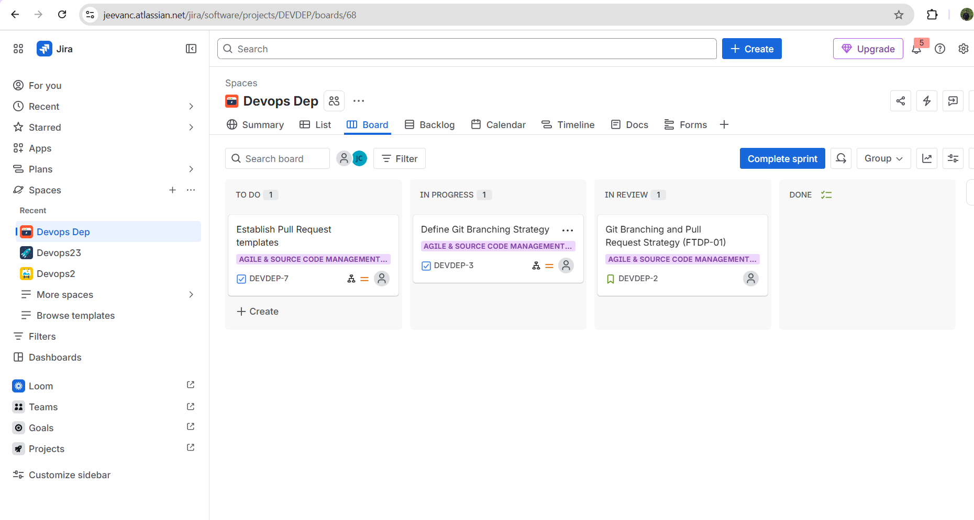
Jira Active Scrum Board showing Sprint progress
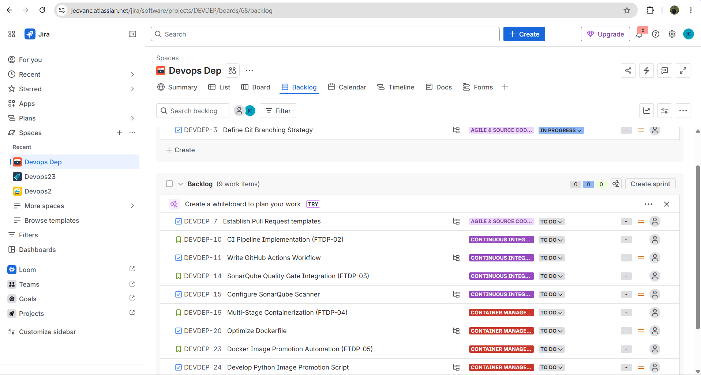
Jira Backlog showing nested Epics, User Stories, and Tasks
- Epic 1: Infrastructure Setup (EKS Cluster, EC2, ECR)
- Epic 2: CI/CD Pipeline (GitHub Actions + SonarQube)
- Epic 3: Kubernetes & Helm Deployment
- Epic 4: GitOps with ArgoCD
- Epic 5: Observability (Datadog) & AI Operations
──────────────────────────────────────────────────────────────────────────────────────────
Deliverable 2: GitHub Repository Branching & PR Strategy
A GitFlow branching strategy is implemented with 4 branches, each mapping to an environment. Repository: https://github.com/JeevanC31/Fitness_Tracker
- master → Production (protected, requires PR + CI pass + SonarQube gate)
- staging → Staging environment (integration testing)
- develop → Development environment (active feature integration)
- feature → Short-lived feature branches (merged via PR)
──────────────────────────────────────────────────────────────────────────────────────────
Deliverable 3 & 4: GitHub Actions CI Pipeline & SonarQube Integration
A two-job GitHub Actions pipeline triggers on every push to master, staging, and develop. SonarQube Quality Gate must pass before Docker image creation proceeds.
- Job 1 — Code Quality & Testing: checkout → Node.js → npm ci → lint → tests → SonarQube scan → Quality Gate
- Job 2 — Docker Build & Push to ECR: AWS credentials → ECR login → docker build → push :branch + :latest
name: Enterprise CI/CD Pipeline
on:
push:
branches: [master, staging, develop]
jobs:
validate:
steps:
- uses: sonarsource/sonarqube-scan-action@master
- uses: sonarsource/sonarqube-quality-gate-action@master
docker-build:
needs: validate
steps:
- uses: aws-actions/configure-aws-credentials@v2
- uses: aws-actions/amazon-ecr-login@v1
- uses: docker/build-push-action@v4
CI Status: ALL JOBS PASSING — Quality Gate PASSED, ECR image pushed successfully.
Screenshot — GitHub Actions Pipeline (All Steps Passing)
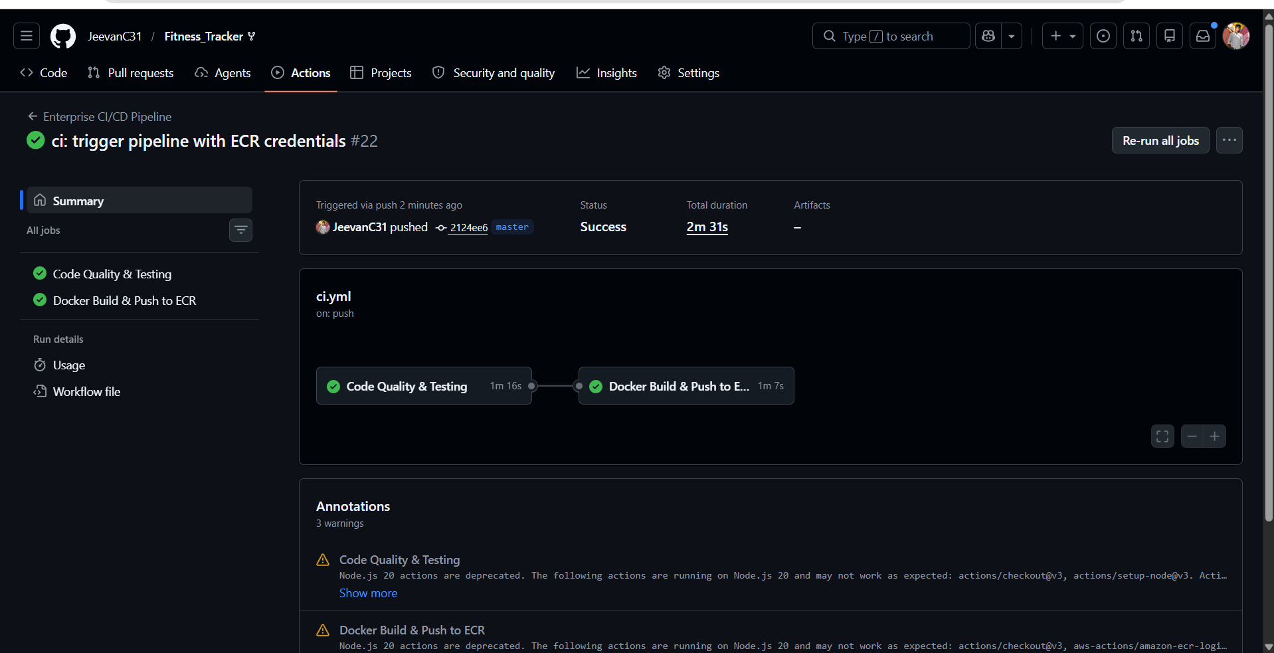
Figure: GitHub Actions CI Pipeline — All jobs passing
Screenshot — SonarQube Quality Gate
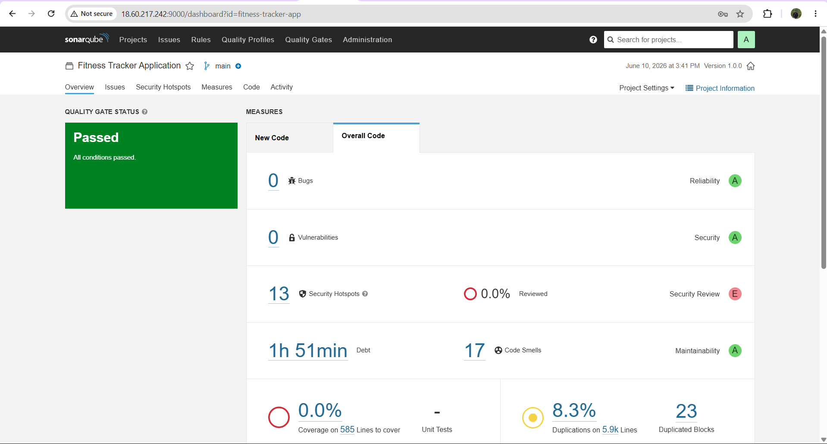
Figure: SonarQube Quality Gate — PASSED
──────────────────────────────────────────────────────────────────────────────────────────
Deliverable 5 & 6: Dockerfile & Image Promotion Automation
Multi-stage production Dockerfile (node:18-alpine) minimizes image size. Images are pushed to AWS ECR and tagged per branch name by the CI pipeline.
FROM node:18-alpine AS builder
WORKDIR /app
COPY package*.json ./
RUN npm ci --only=production
COPY . .
FROM node:18-alpine
WORKDIR /app
COPY --from=builder /app .
EXPOSE 5000
CMD ["node", "server/index.js"]
Promotion Script (scripts/promote_image.py): promotes tested image between environments without rebuilding.
# Promote develop → staging:
python scripts/promote_image.py \
--source-repo <ecr-registry>/fitness-tracker-app \
--target-repo <ecr-registry>/fitness-tracker-app \
--tag develop --target-tag staging
# Promote staging → production:
python scripts/promote_image.py \
--source-repo <ecr-registry>/fitness-tracker-app \
--target-repo <ecr-registry>/fitness-tracker-app \
--tag staging --target-tag master
Screenshot — AWS ECR Image Tags
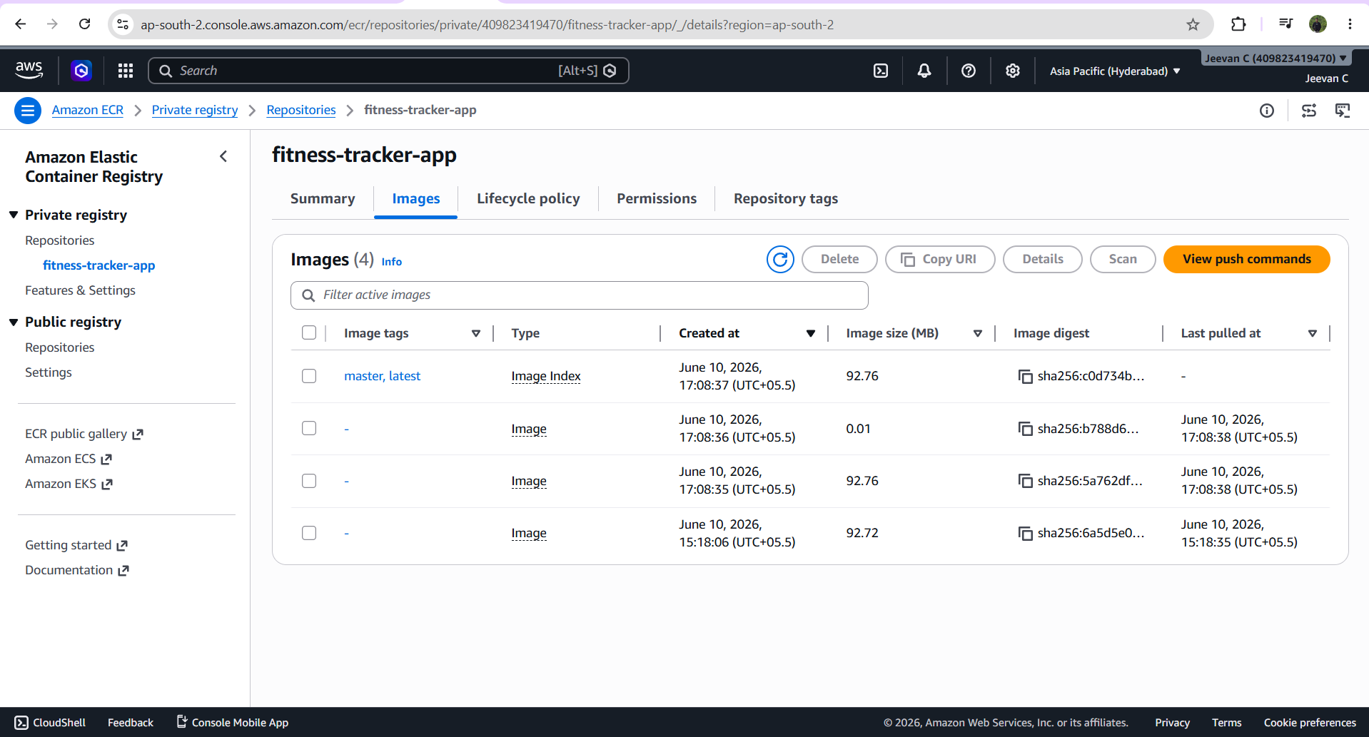
Figure: AWS ECR — fitness-tracker-app image tags: master, staging, develop, latest
──────────────────────────────────────────────────────────────────────────────────────────
Deliverable 7 & 10: Kubernetes Manifests & KGateway Routing
Deployed on AWS EKS (fitness-tracker-cluster, ap-south-2, 3x c7i-flex.large worker nodes). Kubernetes manifests are in the kubernetes/ directory.
- namespace.yaml — environment namespaces (production / staging / dev)
- app-deployment.yaml — 3-replica Node.js app with resource limits & health probes
- mongodb-deployment.yaml — MongoDB with persistent volume
- configmap.yaml — PORT, NODE_ENV, MONGODB_URI
- secrets.yaml — JWT_SECRET (base64 encoded)
- kgateway.yaml — Gateway + HTTPRoute for external traffic → service:5000
Screenshot — EKS Cluster
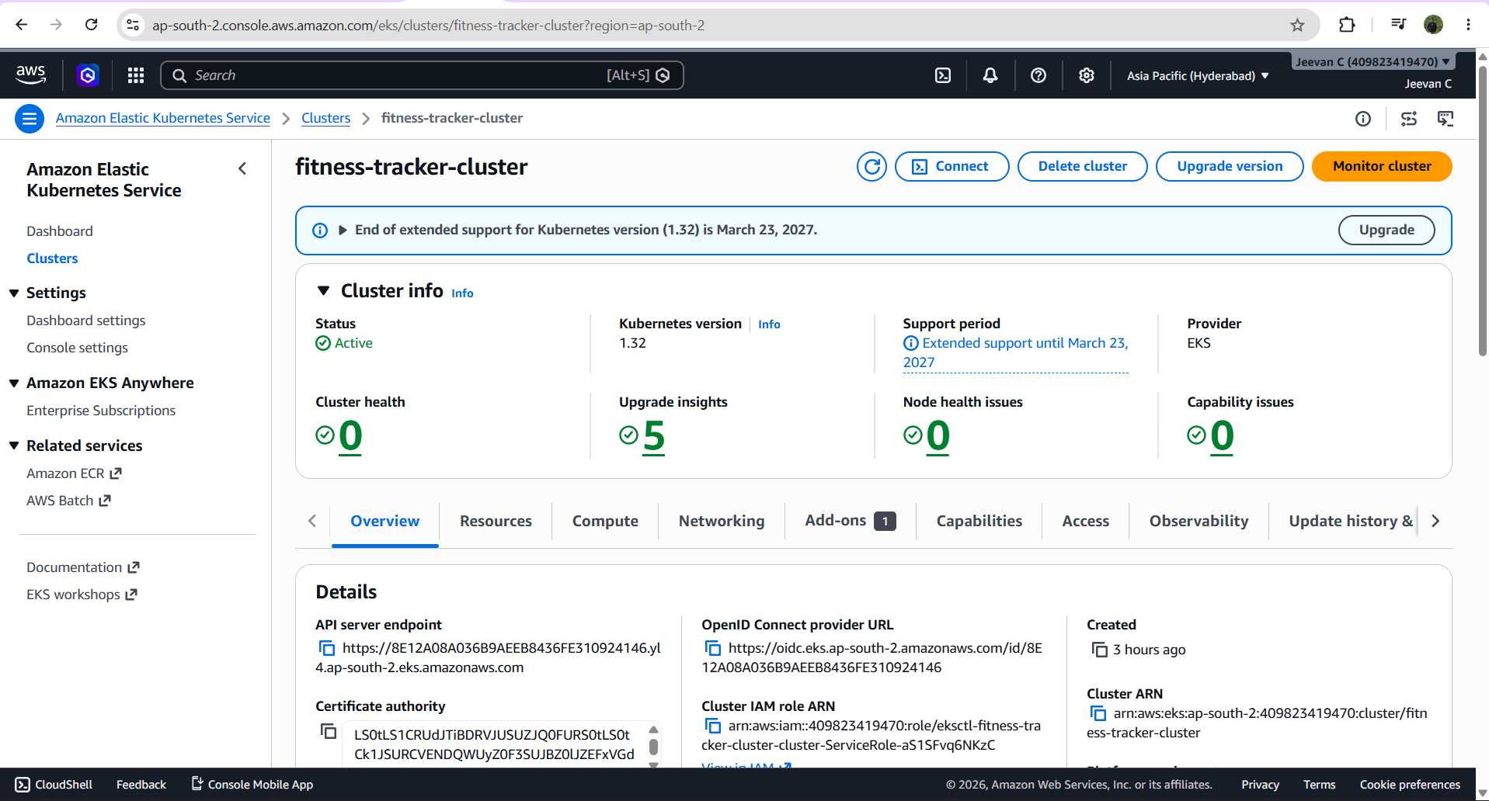
Figure: AWS EKS — fitness-tracker-cluster, 3 worker nodes
Screenshot — Production Pods Running
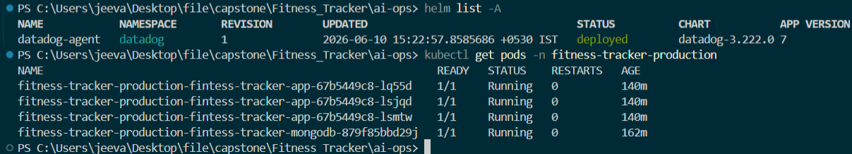
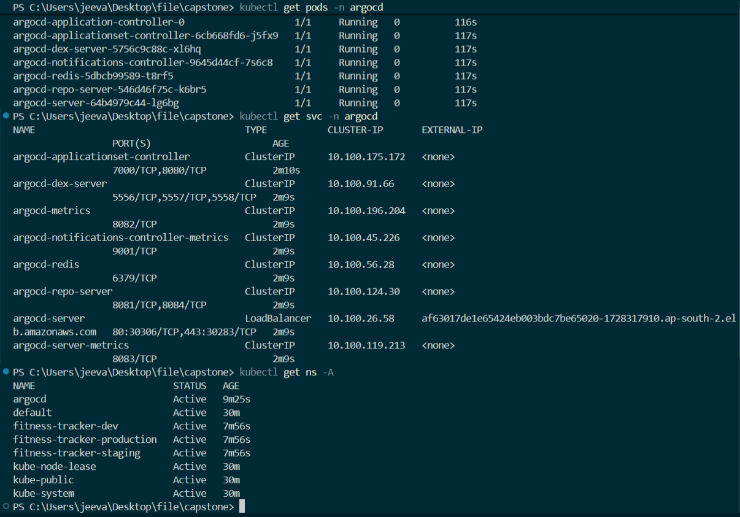
ArgoCD multi-environment health and sync overview
Figure: kubectl get pods -n fitness-tracker-production — all 1/1 Running
──────────────────────────────────────────────────────────────────────────────────────────
Deliverable 8 & 9: Helm Charts & ArgoCD GitOps Deployment
Kubernetes resources are packaged as a Helm chart (Fitness_Chart/) with separate values files per environment. ArgoCD manages 3 Application instances and auto-syncs on every Git push.
- fitness-tracker-dev → tracks develop branch → fitness-tracker-dev NS
- fitness-tracker-staging → tracks staging branch → fitness-tracker-staging NS
- fitness-tracker-production → tracks master branch → fitness-tracker-production NS
spec:
source:
repoURL: https://github.com/JeevanC31/Fitness_Tracker.git
targetRevision: master
path: Fitness_Chart
syncPolicy:
automated:
prune: true
selfHeal: true
All 3 ArgoCD applications: Healthy & Synced.
Screenshot — ArgoCD Dashboard
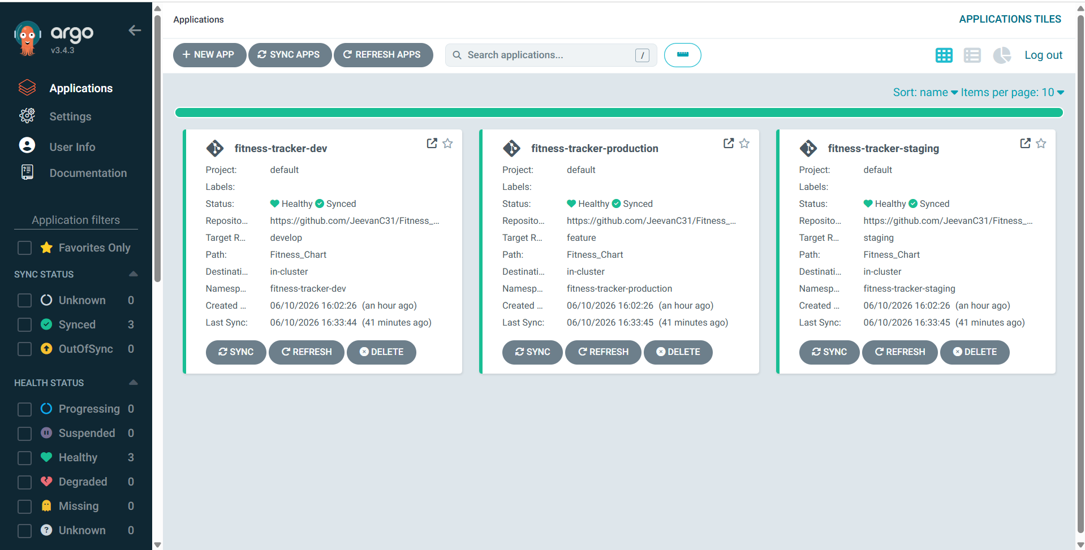
Figure: ArgoCD — 3 applications Healthy & Synced
──────────────────────────────────────────────────────────────────────────────────────────
Deliverable 11 & 12: Datadog Observability & AI SRE Operations Agent
Datadog DaemonSet is installed on EKS via Helm collecting metrics, container logs, and APM traces from all 3 worker nodes. Dashboard is defined in datadog/dashboard.json.
helm install datadog-agent datadog/datadog \
--namespace datadog --create-namespace \
--set datadog.apiKey="<datadog-api-key>" \
--set datadog.site="us5.datadoghq.com" \
--set datadog.logs.enabled=true \
--set datadog.logs.containerCollectAll=true
Screenshot — Datadog Monitoring
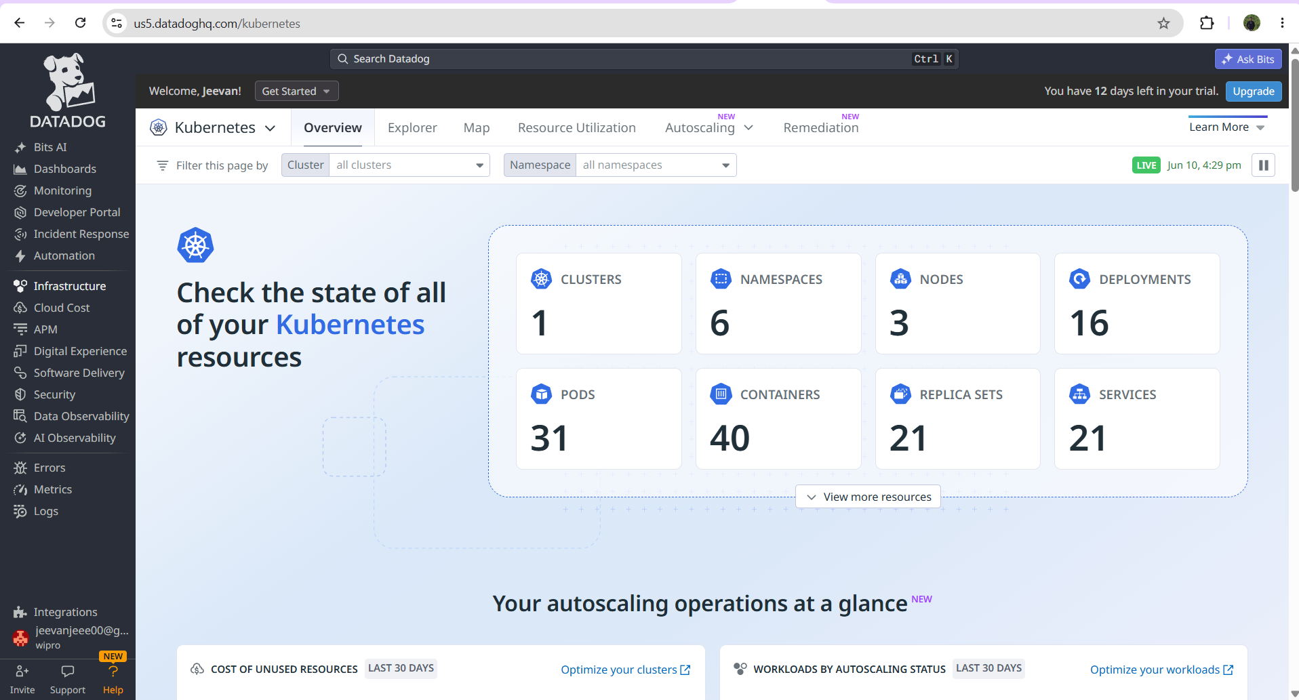
Figure: Datadog — Kubernetes cluster monitoring dashboard
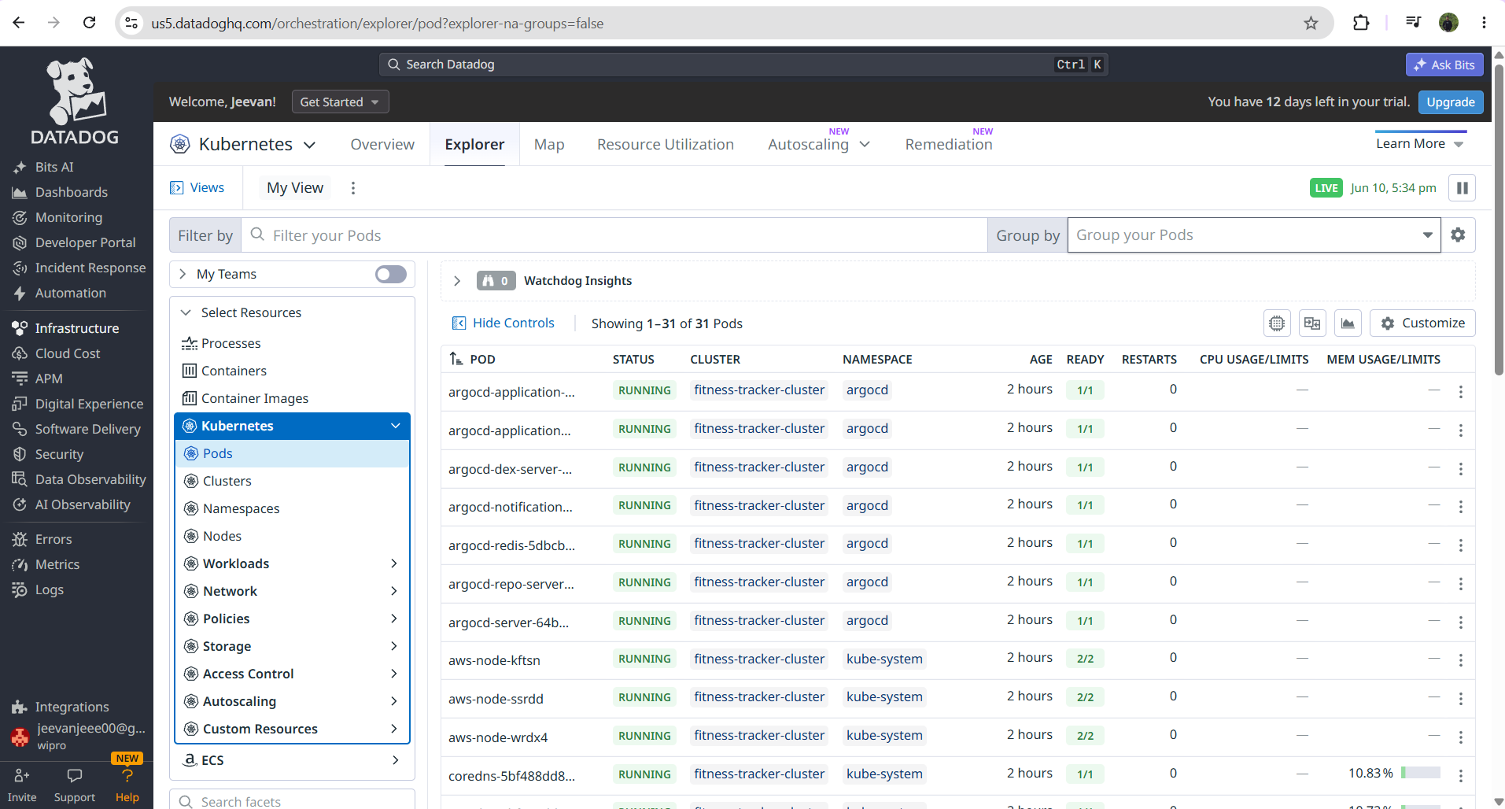
Figure: Datadog — Container metrics and logs
AI SRE Agent (ai-ops/ai_agent.py) scans live pod logs using pattern-matching heuristics and auto-generates kubectl recovery scripts.
cd Fitness_Tracker/ai-ops
kubectl logs -l app=fitness-tracker-production-fintess-tracker-app \
-n fitness-tracker-production --tail=100 | Out-File -Encoding utf8 live_logs.txt
python ai_agent.py --log-file live_logs.txt
→ [OK] Analysis Complete: No known system errors detected.
Screenshot — AI-Ops Agent Output
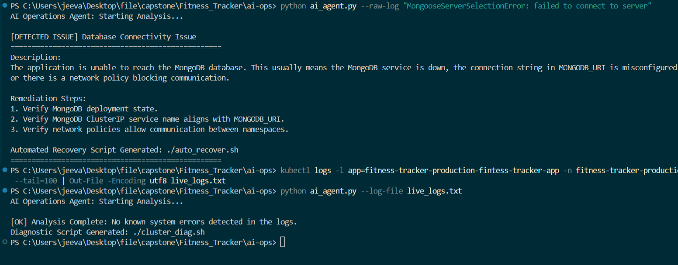
Figure: AI-Ops SRE Agent — log analysis result: No errors detected
──────────────────────────────────────────────────────────────────────────────────────────
Deliverable 13: System Architecture Flow
Developer Workstation
└─ git push ──► GitHub Repository (JeevanC31/Fitness_Tracker)
↓
GitHub Actions CI Pipeline (Ubuntu Runner)
├─ Job 1: lint → tests → SonarQube → Quality Gate
└─ Job 2: docker build → push to AWS ECR (:branch-tag)
↓
AWS ECR fitness-tracker-app:master/:staging/:develop/:latest
↓
ArgoCD (k3s/EC2) polls GitHub every 3 min
├─ fitness-tracker-dev → dev NS
├─ fitness-tracker-staging → staging NS
└─ fitness-tracker-production → production NS
↓
AWS EKS Cluster (ap-south-2, 3x c7i-flex.large)
├─ fitness-tracker-app (3 replicas)
├─ MongoDB (1 replica + PV)
├─ KGateway (external traffic routing)
└─ Datadog DaemonSet (metrics + logs + APM)
↓
http://<elb-dns>.ap-south-2.elb.amazonaws.com ← Live App
↓
AI-Ops Agent ← analyzes logs → auto_recover.sh
Screenshot — Fitness Tracker Application (Live)
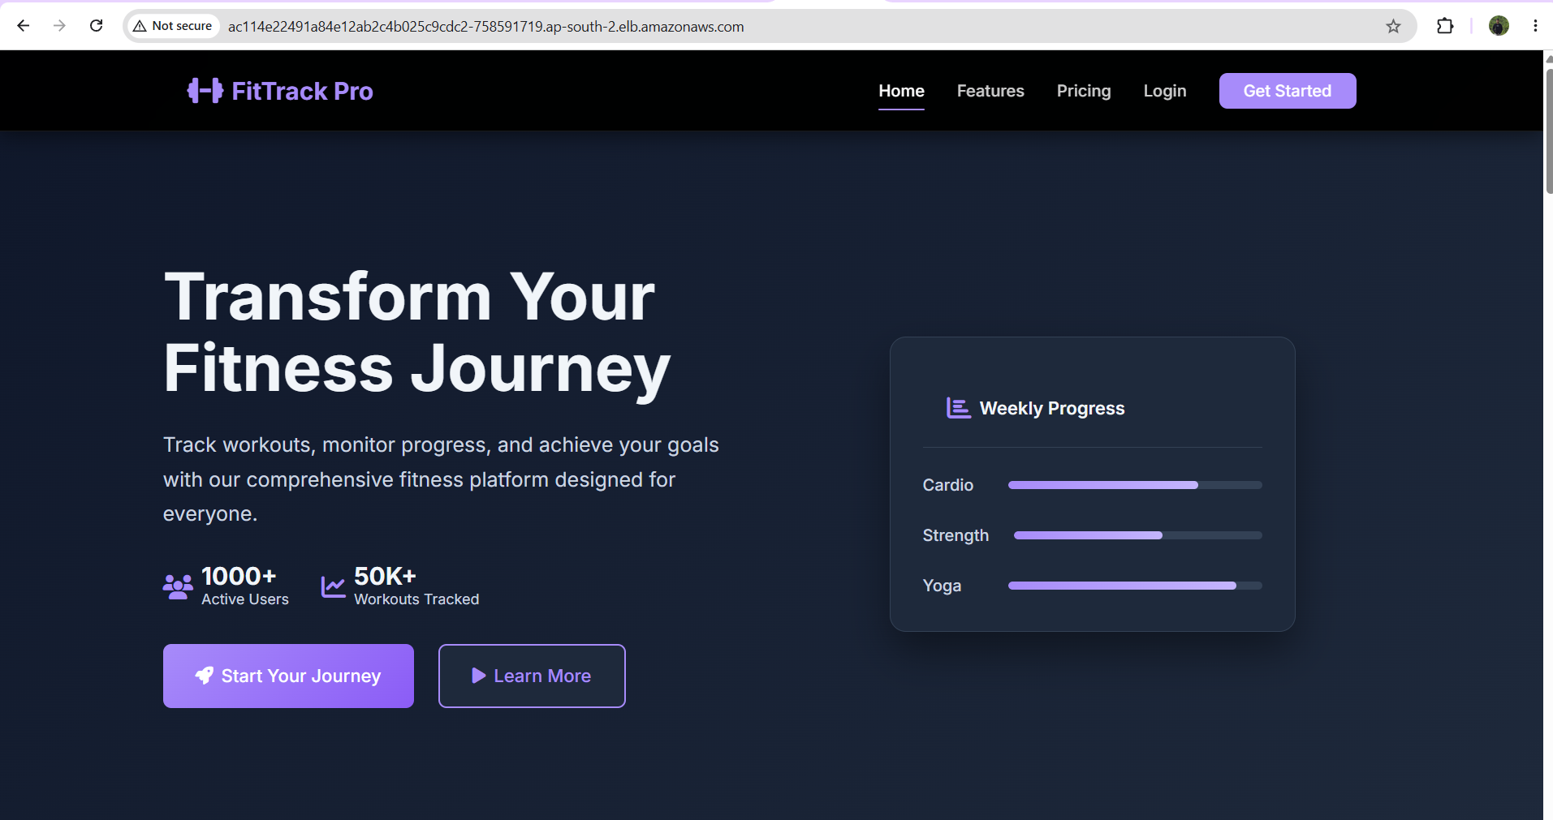
Figure: Fitness Tracker App — running live via AWS EKS LoadBalancer
──────────────────────────────────────────────────────────────────────────────────────────
Deliverable 14: Project Repository & Complete Documentation
GitHub Repository: https://github.com/JeevanC31/Fitness_Tracker
Complete deployment guide: deploy-do.txt (capstone root directory, Phases 1–8)
- .github/workflows/ci.yml — CI/CD pipeline (GitHub Actions)
- Fitness_Chart/ — Helm chart (multi-env: dev/staging/prod)
- argocd/application-*.yaml — ArgoCD app manifests
- kubernetes/ — Raw Kubernetes manifests (6 files)
- ai-ops/ai_agent.py — AI SRE Operations Agent
- scripts/promote_image.py — Docker image promotion script
- datadog/dashboard.json — Datadog dashboard configuration
- docs/ — github_strategy, jira_dashboard, sonarqube_report, architecture_diagram
- sonar-project.properties — SonarQube project config
- eks-cluster-config.yaml — EKS cluster definition (eksctl)
- Dockerfile — Multi-stage production container build

Infrastructure Summary:
EKS Cluster : fitness-tracker-cluster | ap-south-2 | 3x c7i-flex.large
EC2 Server : Ubuntu 22.04, t3.medium | SonarQube :9000 | ArgoCD k3s :32542
ECR Registry: <aws-account-id>.dkr.ecr.ap-south-2.amazonaws.com/fitness-tracker-app
Datadog : us5.datadoghq.com | DaemonSet on all 3 nodes
Repository : https://github.com/JeevanC31/Fitness_Tracker

